**CSC 250 – Program Design Document**

**John Akujobi**

**CSC 150 – Spring 2023**

**Structure Chart**

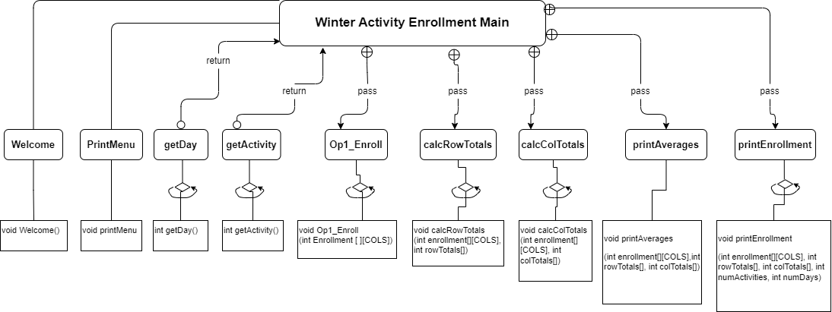

**User Flowchart**

* Welcome message
* Main menu displays
* Inputs the choice
* 1 - Enroll in an activity
  + Sees the list of day
  + Inputs the Day of activities
  + Sees the list of actvities
  + Inputs the Activity type
  + Print the last Enrollment for that day
  + Inputs the new enrollment
* 2 - Print the current enrollment
  + Sees the enrollment show on the screen
* 3 - Exit
  + The program ends
* Repeats the menu

**Function Design (give the prototype and a short description for each function)**

1. printWelcome
   * Prints the welcome message
   * void printWelcome()
   * printWelcome()
2. printMenu
   * prints the Mainmenu
   * void printMenu()
   * printMenu()
3. OP1_Enroll
   * Option to enroll in activity
   * void OP1_Enroll(int enrollment[][COLS])
4. printDay
   * Prints the day based on the input
   * void printDay( int Day)
   * printDay()
5. getDay
   * Prints the list of days, then gets, validates, and returns the chosen day from the user
   * int getDay()
   * getDay()
6. getActivity
   * Prints the acivity list, then gets, validates, and returns the activity type from the user
   * int getActivity()
   * getActivity()
7. calcRowTotals
   * Calculates the total for each row/day enrollment using an array and returns the total enrollment
   * void calcRowTotals(int enrollment[][COLS], int rowTotals[])
   * calcRowTotals(enrollment, rowTotals)
8. calcColTotals
   * Calculates the total for each column/activity enrollment using an array and returns the total enrollment
   * void calcColTotals(int enrollment[ROWS][], int colTotals[])
   * calcRowTotals(enrollment, colTotals)
9. printAverages
   * calculates and prints the average enrollments for each activity and the average daily enrollment
   * void printAverages
   * printAverages()

AVERAGES

______________________

Averages per sport

Skiing🎿 = ##

Curling🥌 = ##

Ice Skating⛸️ = ##

Sledding 🛷 = ##

Average daily = ##

1. printEnrollment

* Prints the enrollment current enrollment in the format below
* void printEnrollment
* printEnrollment

WINTER ACTIVITIES CURRENT ENROLLMENT

___________________________________________

DAYS Sk🎿 Cu🥌 Ic⛸️ Sl🛷 | Total

Day1 | 20 40 20 40 | 120 - Day1

Day2 | 30 60 30 60 | 180 - Day2

Day3 | 40 20 40 20 | 120 - Day3

Day4 | 60 30 60 30 | 180 - Day4

Day5 | 20 40 20 40 | 120 - Day5

____________________________________|______

Total 170 190 170 190 | 720

Total Enrolment = ####

**Time Estimate**

|  |  |  |
| --- | --- | --- |
|  | **Estimated Time** | **Actual Time** |
| Program Design | **4:00 hrs** | **3:30 hrs** |
| (list each function name and the time required to code each) | **Ongoing**  **3hrs expected** |  |
|  |  |  |
|  |  |  |
|  |  |  |
| Program Test |  |  |
| **Total Time** |  |  |